Unofficial Sample Test Plan for
JavaScript Program

Version Details

Version 1.0 | 1st April 2010 | First version
Version 1.0 | 1st April 2010 | First version
Version 1.x | xx | …
Version 1.x | xx | …
Version 1.x | xx | …
Version 1.x | xx | …
Version 1.x | xx | …

Table of Contents

Introduction 3
Test Objective 3
Process Overview 3
Test Strategy 3
White box testing 3
White Box Testing 3
Black Box Testing 4
Testing Program’s Logic 6
Integration Testing 6
Testing entire program with expected values 6
Testing robustness of the second form 7
Bug Report Form 8

Introduction

Sample text for introduction

Test Objective

The main objective is to spot errors and bugs in our program. We will also attempt to spot for logical errors. Any errors, bugs or logical errors spotted will be recorded in the “Bug form”.

Process Overview
The following represents the overall flow of the testing process:
- Identify the scope.
- Identify which particular test(s) will be used to test for each module.
- Select test data.
- Identify the expected results for each test.
- Document the test case configuration, test data, and expected results.
- Perform the test(s).
- Documentation of results ( inclusive of bugs )

Test Strategy

The following outlines the types of testing that will be done for white box testing, black box testing, and integration testing.

White box testing

White Box Testing

We’ll perform unit testing as part of our white box test. The test data is as follows:
Input fields | Input value ( case 1) | Input Value (case 2)
Name | Johnny Boy | Billy Boy
Place of birth | San Francisco | San Francisco
Age | 25 | 25
Spending per month | 1000 | 1000
Salary per month | 100000 | 2000
Age at which you wish to retire at | 55 | 55
Amount of money I want by retirement age | 1000000 | 1000000

The expected output for each of the input values is a dynamically generated input box. Also, the input fild on the left will be disabled. An example can be seen on the following screen shot:
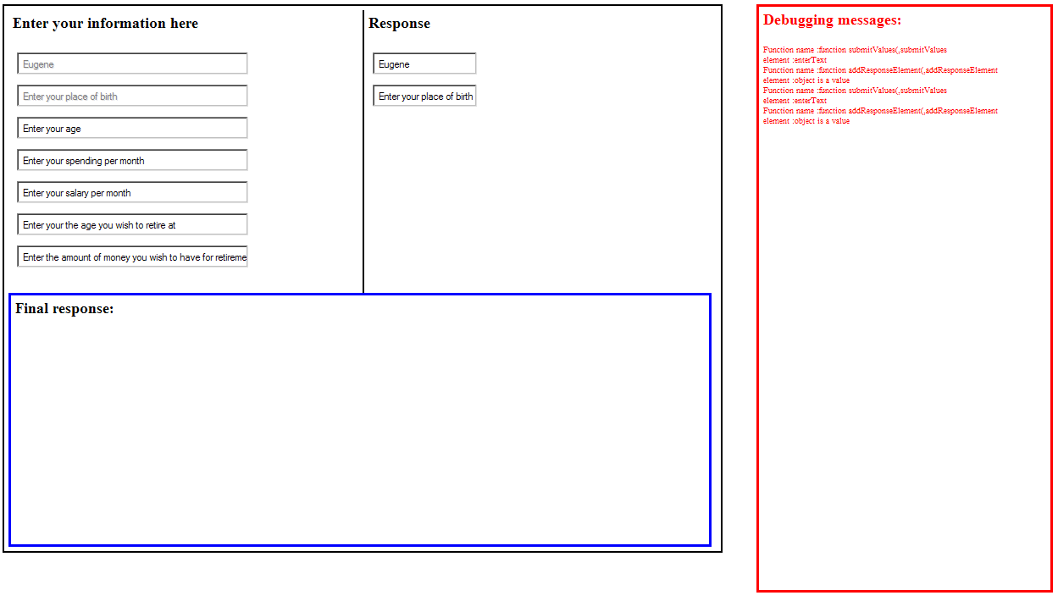

Black Box Testing

Boundary value testing
We will perform black box testing by employing the boundary value testing. The test values are as follows:
Input fields | Minimum Value | Common Value | Maximum value | Comments
Name | A single character, such as ‘a’ | Eugene | An extremely long string, but less than 255 characters. | While the shortest name on Earth could very well be longer than a single character, we are using one single character for demonstration purposes only.
Place of birth | A single character, such as ‘a’ | New York City | An extremely long string, but less than 255 characters.
Age | 1 | 25 | No more than 200 years old | We are assuming that the user is not older than 200 at this point of time
Spending per month | 1 | 2000 | 1000000000
Salary per month | 2 | 5000 | 1000000000 | Notice that that we are assuming that our user earns more than he spends.
Age at which you wish to retire at | This age should be greater than the present age | This age should be greater than the present age | This age should be greater than the present age
Amount of money I want by retirement age | We will be using ‘1’ here | A decent number such as 1,000,000 | No more than a trillion dollars

Testing for illegal values
The next phase of this test is testing for illegal values. The test data are as follows:
Input fields | Input Value
Name | We will be using digits here and empty values
Place of birth | We will be using digits here and empty values
Age | We will be using characters and empty values
Spending per month | We will be using characters and empty values
Salary per month | We will be using characters and empty values
Age at which you wish to retire at | We will be using characters and empty values
Amount of money I want by retirement age | We will be using characters and empty values

In general the output for each of the above invalid output would be an alert box telling us that we have input an incorrect value.

Testing Program’s Logic
We will test for the program’s logic in terms of user’s age versus its retirement age. The user’s age should be of smaller value than his desired retirement age. As such the test data is as follows:
Input fields | Input value of first form
Name | Johnny Boy
Place of birth | San Francisco
Age | 30
Spending per month | 1000
Salary per month | 2000
Age at which you wish to retire at | 25
Amount of money I want by retirement age | 1000000
If our program does not spot this error, than it has a bug.

Integration Testing
There are two parts to this test: testing the entire program and changing value of the second form.

Testing entire program with expected values
The test data of the program is as follows:
Input fields | Input value ( case 1) | Input Value (case 2) | Input Value (case 3) | Input Value (case 4)
Name | Johnny Boy | Johnny Boy | Johnny Boy | Johnny boy
Place of birth | San Francisco | San Francisco | San Francisco | San Francisco
Age | 25 | 25 | 25 | 25
Spending per month | 1000 | 1000 | 1000 | 1000
Salary per month | 100000 | 2000 | 2000 | 100000
Age at which you wish to retire at | 55 | 55 | 28 | 28
Amount of money I want by retirement age | 2000000 | 2000000 | 1000000 | 100000

The output for case 1 and 3(unable to retire on time) is
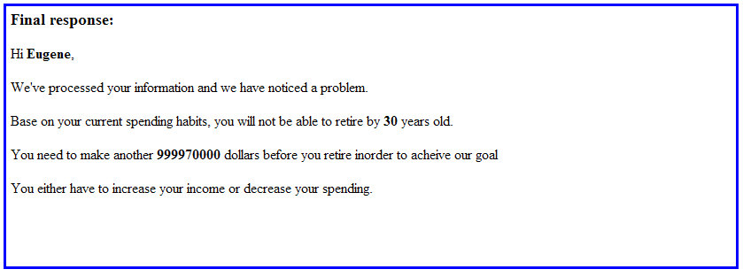

The output for case 2 and 4 (able to retire on time) is
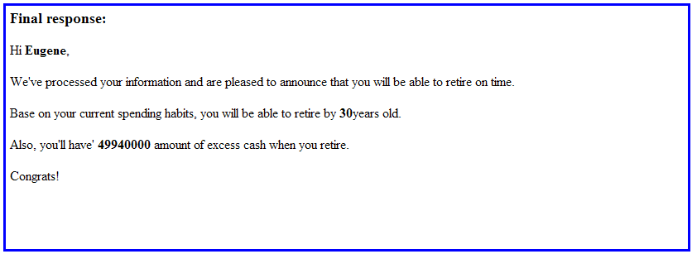

Testing robustness of the second form
We will attempt to test the robustness of the program by changing values in the second form. The test values are as follows:
Input fields | Input value of first form | Input Value the second form (random values)
Name | Johnny Boy | 25
Place of birth | San Francisco | 100
Age | 25 | Johnny Boy
Spending per month | 1000 | Some characters
Salary per month | 100000 | More characters
Age at which you wish to retire at | 20 | Even more characters
Amount of money I want by retirement age | 1000000 | 1000000
We should expect the program to inform us of the error in the second form.

Bug Report Form

The following bug(s) are found:

Bug Number | Phase | Actions leading to error | Possible remedies | Comments
1. | Testing expected and unacceptable values – boundary testing | Entering a single character | Change the function such that it checks for minimum length for character input. | Program accepts single characters as inputs - unrealistic
2. | Testing expected and unacceptable values – boundary testing | Entering values of more than 1,000,000,000 and strings that are more than 255 characters. | Change or add a function checks for maximum length for character input. | Program does not have a maximum boundary – unrealistic and can be fatal.
3. | Testing expected and unacceptable values – testing negative values | Entering negative values for input fields that require numeric inputs | Include a function that checks for negative values and produces a correct output | Entering negative values results in an incorrect output of “input must be digit”
4. | Testing program logic | Entering a retirement age value that is smaller than the present age. | Create a function that can spot this error before form submission | This error is fatal for our program
5. | Integrated testing | Changing values in the second form | Create function that checks the second form | This error is fatal for our program

